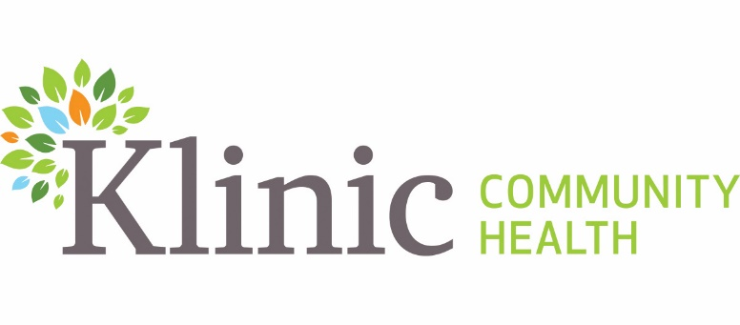
Job Posting #2024-091
Internal/External Posting
Posting Date: Oct. 8, 2024
Posting End Date: Oct. 15, 2024
Union: Exempt

PROJECT COORDINATOR
Full-Time Term to March 31, 2025
Part-Time Term 0.3 EFT April 1, 2025 to March 31, 2026
Part-Time Term 0.2 EFT April 1, 2026 to March 31, 2027

HOURS OF WORK: Days, (Occasional evenings and weekends may be required)
START DATE: As soon as possible

Klinic Community Heath is a pro-choice community health centre that provides primary care, education and counselling services to our local community and throughout Manitoba. Driven by our vision of creating healthy and engaged communities, we promote health and quality of life for people of every age, background, ethnicity, gender identity and socio-economic circumstances. Rooted in social justice values, we believe that everyone deserves quality care, support and respect.

POSITION SUMMARY

Klinic Community Health has received grant funding to evaluate and review federal government programming related to sexual misconduct supports specifically within the Department of National Defence (DND), and the Canadian Armed Forces (CAF).

This is a three-year position that will support the development and implementation of an online training portal to provide public education for service providers within DND and CAF. The successful candidate will also be required to plan and execute a full-day conference to engage and share knowledge with other organizations that provide services to those affected by sexual assault and intimate partner violence.

Under the direction of the Director of Development, the incumbent applies project management principles, tools and templates throughout the project life cycle including the initiation, planning, executing, controlling and closing phases. The incumbent will support and manage project scope, resources, communications, risks/issues, budget, timelines, procurement, integration, quality, and implementation.

The incumbent will be the point of interaction and coordination for all entities involved in the project.

QUALIFICATIONS:
Please note that an equivalent combination of relevant education and experience may be considered:
- Minimum three years of project coordination/management experience, previous training in project management preferred
- Experience managing projects with internal staff and external stakeholders
- Proven experience leading team projects including planning, managing and implementation
- Demonstrated ability to prioritize workload and respond to simultaneous demands
- Demonstrated critical thinking, conflict resolution and decision-making skills
- Strong interpersonal skills are required.
- Ability to work with a wide variety of groups, including marginalized groups is required
- Demonstrated understanding of health equity and how it impacts patient care, experience and outcomes.
- Familiarity with the Truth and Reconciliation Calls to Action and the MMIWG2S+ Calls to Justice and demonstrated commitment to disrupting all forms of racism and oppression, including homophobia and transphobia, within systems and practices.
- Demonstrated understanding and commitment to holistic health care and a strong understanding of the social determinants of health and the systemic impacts that contribute to accessible and equitable care for individuals, families and communities.
- Grounding in trauma-informed practices and cultural safety.
- Familiarity with accessibility standards and practices.
- Knowledge of best practices, national and provincial standards, and legislation inclusive of Personal Health Information Act (PHIA)
- Proficiency in related software (Microsoft Office, Outlook).

SKILLS AND ATTRIBUTES:
- Alignment with Klinic’s Vision, Mission, and Values.
- Strong commitment to trauma-informed, culturally safe care, with an emphasis on equity, diversity, inclusion, and accessibility.
- Experience working in a healthcare setting preferred
- Experience managing budgets
- Demonstrated ability to participate in and contribute to a strong team environment with an inclusive and collaborative approach.

RESPONSIBILITIES:
- Monitors and follows-up on the delivery of project activities
- Develops and maintains project schedule
- Conducts project monitoring and reports on status
- Identifies late or incomplete tasks and initiates corrective action with project staff member directly or through responsible team lead
- Initiates problem solving and issue resolution as required
- Develops and recommends mitigation strategies for project risks as necessary
- Assigns project tasks to team members
- Establishes and leads ad hoc project task teams as required
- Develops and provides overall project orientation to new staff and consultants
- Directs project staff to ensure completion of assigned tasks
- Provides guidance and direction to contractors and team members to determine when an issue requires escalation
- Validates completeness of tasks
REQUIREMENTS:
- Satisfactory Criminal Record, Child Abuse and Adult Abuse Registry checks

SALARY $28.834 to $38.720 per hour

APPLICATION PROCESS
- Application Deadline October 15, 2024
- E-mail cover letter and resume to: jobs@klinic.mb.ca
- Please note “Job Posting #2024-091- in all correspondence

Klinic is committed to working towards having a more equitable and diverse work force at all levels of our organization. We welcome and encourage persons who reflect the diversity of the communities we serve to apply, those who identify as Indigenous, Black, Persons of Colour, 2SLBGTQQIA+, and /or those living with disabilities. Applicants are invited to self-declare in their cover letter.

Accommodations are available upon request during the assessment and selection process. Applicants are asked to please self-declare in their cover letter.

Thank you for your interest. Only candidates selected for an interview will be contacted.

