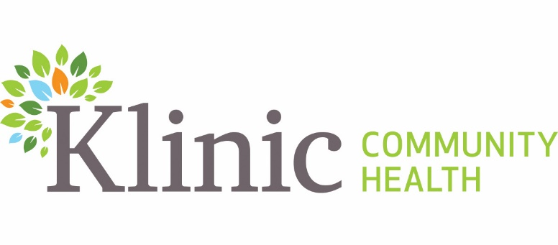
Job Posting #2024-090
Internal/External Posting
Posting Date: Oct. 8, 2024
Posting End Date: Oct. 15, 2024
Union: Exempt

RESEARCH COORDINATOR
PART TIME TERM POSITION

0.6 EFT (24 Hours Per Week)
HOURS OF WORK: Days, (Occasional evenings and weekends may be required)
START DATE: As soon as possible
TERM ENDING: March 31, 2025

Klinic Community Heath is a pro-choice community health centre that provides primary care, education and counselling services to our local community and throughout Manitoba. Driven by our vision of creating healthy and engaged communities, we promote health and quality of life for people of every age, background, ethnicity, gender identity and socio-economic circumstances. Rooted in social justice values, we believe that everyone deserves quality care, support and respect.

POSITION SUMMARY

Klinic Community Health has been awarded grant funding to evaluate and review Federal Government programming specifically in the Department of National Defence, and the Canadian Armed Forces. The evaluation will review the post trauma sexual assault and violence programming responses and resources available to those who identify in as a part of the 2SLGBTQQIA+, BIPOC and respective staff communities of the DND and CAF. As part of the Hummingbird program, this position will review the programs available to CAF and DND staff persons, and compose a written document and feedback review, and subsequently identify any gaps of which training will be developed to support the translation of knowledge pertaining to these gaps. All services at Klinic are delivered through an empowerment based, trauma-informed lens, and within the broader context of the social determinants of health.
QUALIFICATIONS:
Please note that an equivalent combination of relevant education and experience may be considered:
- A Bachelor of Science degree in health, social, or behavioural sciences or equivalent education and experience
- Minimum 2-year experience in research and project or program coordination
- Advanced level of proficiency in Microsoft Office, Adobe Acrobat applications and database creation
- Previous experience working within a research environment
- Experience with using social media as a tool for the community education and knowledge translation for research studies
- Strong interpersonal skills are required. Must be able to engage patient participants in the research project.
- Ability to work with a wide variety of groups, including marginalized groups is required
- Demonstrated understanding of health equity and how it impacts the patient care experience and outcomes
- Knowledge and clinical experience related to the following: risk assessment, crisis intervention, suicide prevention, trauma recovery, gender-based violence, sexual assault, mental health, substance use/addiction, harm reduction, suicide bereavement and sexual exploitation.
- Familiarity with the Truth and Reconciliation Calls to Action and the MMIWG2S+ Calls to Justice and demonstrated commitment to disrupting all forms of racism and oppression, including homophobia and transphobia, within systems and practices.
- Demonstrated understanding and commitment to holistic health care and a strong understanding of the social determinants of health and the systemic impacts that contribute to accessible and equitable care for individuals, families and communities.
- Grounding in trauma-informed practices and cultural safety.
- Familiarity with accessibility standards and practices.
- Knowledge of best practices, national and provincial standards, and legislation inclusive of Personal Health Information Act (PHIA)
- Proficiency in related software (Microsoft Office, Outlook).

SKILLS AND ATTRIBUTES:
- Alignment with Klinic’s Vision, Mission, and Values.
- Strong commitment to trauma-informed, culturally safe care, with an emphasis on equity, diversity, inclusion, and accessibility.
- Experience working in a healthcare setting preferred
- Previous experience coordinating research studies
- Experience managing study budgets
- Ability to design and implement research surveys
- Active member in good standing with an associated regulatory body as appropriate.
- Foster an environment of quality, safety, continuous improvement, and innovation, ensuring all aspects prioritize cultural safety.
- Demonstrated ability to participate in and contribute to a strong team environment with an inclusive and collaborative approach.

RESPONSIBILITIES:
- Develop and maintain a project work plan outlining daily, weekly and monthly outcomes
- Establish and facilitate a community-based research cohort inclusive of support from, Elders and field experts responsible for the designing of the project and curriculum.
- Establish and facilitate regular meetings with the cohort to ensure community members are actively engaged in the designing of the content and curriculum
- Establish and maintain strategic partnerships with other crisis distress centers and organizations who respond to community needs for crisis intervention
- Develop the final Training Module, and facilitate training groups both within Klinic and externally
- Review the implementation and evaluation and revision of the curriculum based on participant feedback
- Maintain program statistics, complete written reports, and complete evaluation processes as required.
- Maintain project budget spreadsheets inclusive of supplies, and honoraria.
- Reporting to manager of Crisis program on deliverable and timelines
REQUIREMENTS:
- Satisfactory Criminal Record, Child Abuse and Adult Abuse Registry checks

SALARY $33.00 per hour

APPLICATION PROCESS
- Application Deadline October 15, 2024
- E-mail cover letter and resume to: jobs@klinic.mb.ca
- Please note “Job Posting #2024-090- in all correspondence

Klinic is committed to working towards having a more equitable and diverse work force at all levels of our organization. We welcome and encourage persons who reflect the diversity of the communities we serve to apply, those who identify as Indigenous, Black, Persons of Colour, 2SLBGTQQIA+, and /or those living with disabilities. Applicants are invited to self-declare in their cover letter.

Accommodations are available upon request during the assessment and selection process. Applicants are asked to please self-declare in their cover letter.

Thank you for your interest. Only candidates selected for an interview will be contacted.

